Particulate Matter in Chorley
An assessment of the Zephyr continuous air quality monitors

August 2023

Table of Contents
Table of Contents ii
Report Summary iii
Introduction 1
1.1 UK Policy Context 3
1.2 WHO Air Quality Guidelines 3
1.3 Health 4
1.4 Ultrafine Particles 5
1.5 Particulate Monitor Trial 6
Methodology 7
2.1 Equipment 7
2.2 Time Period 8
2.3 DEFRA Background Maps 8
2.4 Note on the Presentation of Data 9
Results 10
3.1 Effects of Time Averaging 10
3.2 Abnormal Events 13
3.3 Seasonal Variation 14
3.4 Annualised Data 16
3.5 Comparison to DEFRA Background maps 18
4. Conclusions 19
5. Glossary 21
6. References 22

Report Author: | Email: | Telephone: | Date:
Matt Evans  Air Quality & Climate Change Officer | contact@chorley.gov.uk | - | August 2023

Report Summary

Particulate matter pollution is of concern due to the health effects and increasing levels associated with the use of solid fuel burners in residential areas. As solid fuel burning increases, the contribution of particulate matter from these sources is growing, shifting focus away from busy roads to residential areas.
This report presents an appraisal of the EarthSense Zephyr continuous particulate monitors trialled during 2022 at three locations across Chorley Borough. The aim was to assess their operation at known areas of high vehicle movements, by collecting data over a full year and to obtain a baseline level of particulate matter concentrations. The data have been compared to both the UK Air Quality Objectives and the World Health Organisation Air Quality Guidelines.
Analysis of the data shows that the particulate matter levels meet our obligations under UK local air quality management guidance and do not exceed UK Air Quality Objective limits. Furthermore, there are no exceedances of the World Health Organisation Interim Target 4 for particulate matter.
This study only considers the validation, operation and data collection of the Zephyr monitoring system in a single year. Therefore, firm associations with particulate matter sources or possible health effects have not been made, except in general terms. Additional work will be required to establish these at a local level. The report instead provides a baseline year from which to compare future Borough-wide particulate matter concentrations.
Chorley Council continues to invest in our air quality programme, which includes monitoring and reporting on levels of particulate matter pollution annually and identifying new monitoring locations. We are also trialling methods to increase public participation in the annual review of monitoring locations and ways to make the data more accessible.
Information on how to reduce particulate matter, energy efficiency and sustainable transport can be found on the website using this link to the Chorley Air Quality webpage and this link to the Chorley Climate Change webpage. Residents should continue to heat their homes appropriately to remain safe and healthy.

Introduction

  - This report only considers particulate pollution affecting Chorley Borough and the functioning of the EarthSense Zephyr monitoring system. No consideration of the health or environmental effects of the particulate matter levels across the Borough will be discussed, except in general terms.

  - This report has not undergone peer-review and has been produced by the Chorley Coucil Air Quality Officer for information. It is additional to the nitrogen dioxide monitoring programme as reported in the Annual Status Reports which are submitted to DEFRA each year.

  - Further information regarding the air quality monitoriong programme as a whole, including Borough nitrogen dioxide levels, is presented in the Annual Status Report (ASR). The most recent reports are available on Chorley Council’s Air Quality website, using this link to the Chorley Air Quality webpage.

  - Chorley’s main air pollutants of concern are those associated with traffic or burning:
- Nitrogen dioxide (NO₂)
- Particulate matter (PM)

  - Over the past few decades, PM levels have roughly correlated with levels of NO₂, with traffic being the main source. Transitioning to electric vehicles and increases in domestic solid fuel burning is altering this link.

  - UK-wide about 15 % of total particulate matter comes from natural sources, e.g., pollen and sea spray, and a third is carried from other countries. About half of PM comes from UK sources such as, wood burning, and tyre, brake and road surface wear from vehicles. (DEFRA, 2023a)

  - PM levels decreased up to the late-2000s, since then emissions have fluctuated. Decreases from some sectors have been offset by increases from wood and solid fuel burning in domestic settings and solid fuel (biomass) burning by industry. (DEFRA, 2023b)

  - The UK is currently focused on measuring two sizes of particulate matter where particles are less than 10 micrometres (µm) in diameter (PM₁₀) and less than 2.5 micrometres (PM_{2.5}). This is based on the latest evidence on the effects of PM to health and the capabilities of currently available monitoring technology. A size comparison of PM is shown in Figure 1.

  - Particulate matter is measured and reported as a concentration, in micrograms (µg) per cubic metre (m³) of air.

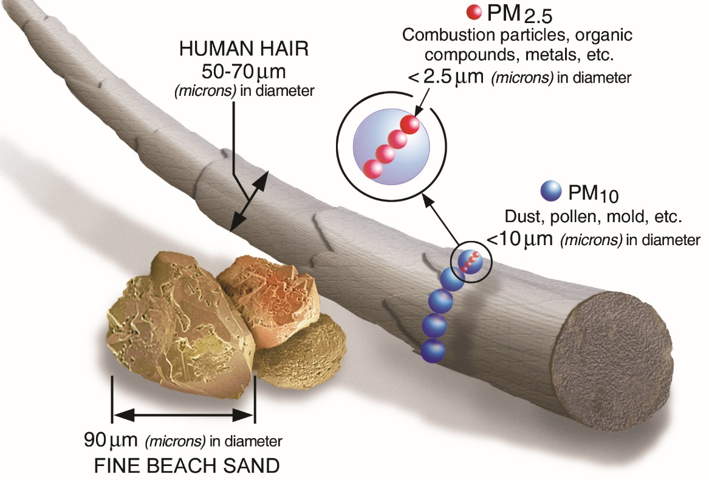
Figure 1: Size comparison for PM particles. Image: US EPA, 2023

  - Domestic combustion is a major source of particulate matter emissions, making up 16 % of PM₁₀ and 27 % of PM_{2.5} emissions. Most comes from households burning wood and solid fuels in stoves and open fires. Emissions of PM_{2.5} from domestic wood burning increased by 124 % between 2011 and 2021, to represent 21 % of total PM_{2.5} in 2021. (DEFRA, 2023b)

  - Road transport represented 12 % of PM₁₀ and 13 % of PM_{2.5} of particulate matter emissions in 2021. (DEFRA, 2023b)

  - Vehicle exhaust emissions have decreased over time due to stricter emissions standards (by 90 % for PM₁₀ and PM_{2.5}). Brake, tyre and road wear represented 10 % of PM₁₀ and PM_{2.5} emissions in 2021. (DEFRA, 2023b)

  - Ammonia (NH₃) is emitted from agricultural activities and has negative effects on ecosystems and leads to the creation of secondary PM_{2.5} which can affect health over wide areas. NH₃ emissions have changed little over the last decades. It is possible to reduce NH₃ by a combination of liquid manure (slurry) covering and changing how slurry is applied to fields. (DEFRA, 2023c)

  - Research suggests agricultural sources of ammonia account for 25–39 % of urban PM_{2.5} pollution. (Kelly, et al., 2023) (Air Quality Expert Group, 2018)

  - For Chorley, the road and motorway network are a major source of vehicle particulate matter pollution. The UK averages, if applied to the Borough, are likely to be skewed by this.

  - It should be noted that without further study, the total contributions from all sources (including solid fuel burning) are difficult to establish. (Lancashire County Council, 2022)

1.1 UK Policy Context
  - As detailed in UK Policy Guidance LAQM.PG22 (Chapter 8), local authorities are expected to work towards reducing emissions and/or concentrations of PM_{2.5} (particulate matter with an aerodynamic diameter of 2.5µm or less). (DEFRA, 2022)

  - The national Air Quality Objectives and Air Quality Standards Regulations set limit and target values with which the UK must comply and are summarised in the National Air Quality Objectives of the UK Air Quality Strategy. (UK AIR, n.d.)

  - A lower target encompassing fine particulate matter (PM_{2.5}) was introduced as a UK Statutory Instrument in 2023, this replaced the previous objective of 20 µg/m³. (UK Government, 2023)

  - Table 1 lists the UK Air Quality Objectives for particulate matter.
Table 1: UK Air Quality Objectives for England (UK AIR, n.d.)
Pollutant | Air Quality Objective | Time Period Measured as
Particulate Matter (PM₁₀) | 50 µg/m³, not to be exceeded more than 35 times a year | 24-hour mean
Particulate Matter (PM₁₀) | 40 µg/m³ | Annual mean
Particulate Matter (PM_{2.5}) | 10 µg/m³ (Target by the end of 31st December 2040) | Annual mean

1.2 WHO Air Quality Guidelines
  - The World Health Organization (WHO) Air Quality Guidelines provide evidence-based, non-binding recommendations for protecting public health from the adverse effects of air pollutants by reducing exposure and by guiding national and local authorities in risk management decisions. (World Health Organization, 2021a)

  - These guidelines have not been adopted by the UK Government.

  - Table 2 lists the WHO Air Quality (AQ) Guideline and Interim Targets for particulate matter, PM₁₀ and PM_{2.5}.

  - Interim targets are included to progressively reduce air pollution to guideline levels and are intended for high air pollution areas. Authorities in polluted areas can use them to develop reduction policies that are achievable within realistic time frames.

  - They are not intended to be a “standard” for air quality in their own right and should be considered in a local context with regards to economic and social factors and local conditions. (World Health Organization, 2021b)
Table 2: WHO Recommended Air Quality (AQ) Guideline Levels and Interim Targets (IT) 1-4. Expressed as µg/m³. (World Health Organization, 2021a)
Pollutant | IT 1 | IT 2 | IT 3 | IT 4 | AQ Guideline | Time Period
Particulate Matter (PM₁₀) | 150 | 100 | 75 | 50 | 40 | 24-hour mean
Particulate Matter (PM₁₀) | 70 | 50 | 30 | 20 | 15 | Annual mean
Particulate Matter (PM_{2.5}) | 150 | 100 | 75 | 50 | 45 | 24-hour mean
Particulate Matter (PM_{2.5}) | 35 | 25 | 15 | 10 | 5 | Annual mean

Health
  - Health risks associated with PM₁₀ and PM_{2.5} are well documented. [For more information see references] (Whitty, 2022) (Asthma and Lung UK, 2022)

  - Particulate matter is capable of penetrating deep into lung passageways and entering the bloodstream causing cardiovascular, cerebrovascular, and respiratory impacts, as well as affecting other organs, as shown in Figure 2.

  - It is not possible to see detailed local correlations between PM and health. Many of the conditions affected by air pollution are caused or worsened by other factors (e.g., lifestyle, socioeconomic status, ethnicity, housing conditions etc.), and some data are not available to ward level. However, it is known that some people are more vulnerable to the effects of air pollution and looking to protect those who will be most impacted should help to reduce health inequalities.

  - Whilst it is possible to estimate the overall proportion of premature deaths (under 75) that may be attributable to particulate matter (using a method outlined in a document published by the Local Government Association, DEFRA and Public Health England), it is usually considered to be a contributory factor rather than a direct cause.

  - Chorley’s Health Protection Officer has undertaken some preliminary research on the local health context of PM_{2.5} on residents. Calculations based on 2015-2017 data suggest that the 'premature mortality' rate in Chorley Borough attributable to all particulate matter is 13.5 per 100,000 population. This compares to 13.9 in Lancashire-12, and 16.9 in England.

  - Data from the LGA and the Office for Health Improvement and Disparities suggests that in 2021, the fraction of annual all-cause adult mortality attributable to anthropogenic (human-made) particulate air pollution (measured as fine particulate matter, PM2.5) in Chorley was estimated at 5.4%, this is the highest of all local authority districts in Lancashire. The mean fraction of annual all-cause adult mortality attributable to anthropogenic PM2.5 air pollution for Lancashire was 4.7%, and 5.4% for all English single tier and district councils. (Local Government Association, 2023)

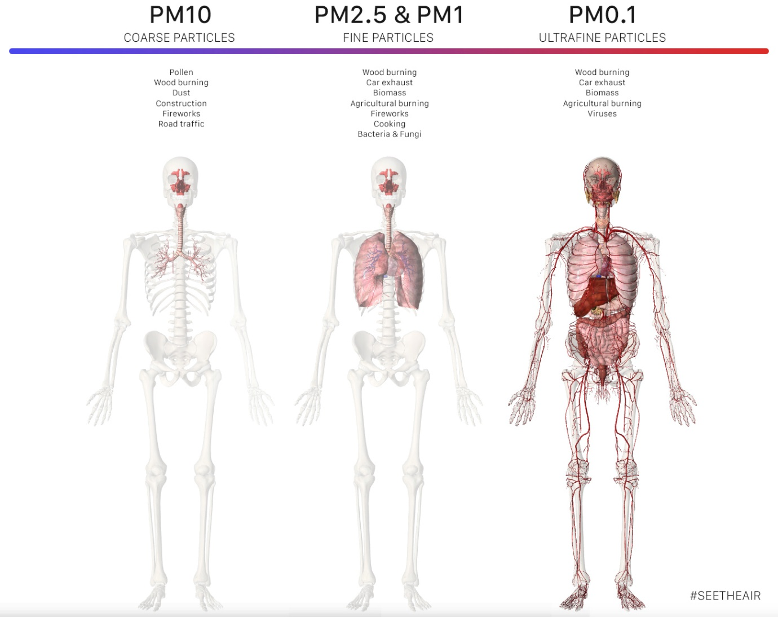
Figure 2: Parts of the Body Affected by Particulate Matter. Image:
See the Air, 2021

1.4 Ultrafine Particles
  - Ultrafine Particles have a particle diameter of less than or equal to 0.1 μm.

  - Studies have shown that the health effects of exposure to ultrafine particles could be more pronounced than for PM₁₀ or PM_{2.5}, as they are able to penetrate further into the body.

  - The research which has been published uses different particle sizes and exposures times, thereby preventing comparison of results across studies.

  - Based on this, the WHO decided the evidence available was not sufficient to produce a guidance level and research is on-going. (World Health Organization, 2021a)

  - The most significant process generating ultrafine particles is combustion of fossil fuels and biomass. The main sources are vehicles, aviation, shipping, industry, power plants and residential heating.

  - Due to the nature of the emissions and particles, variation across an area is substantially larger than the variation of larger particles.

  - Estimation of exposure to ultrafine particles in epidemiological studies is more complex than the assessment of exposure to PM_{2.5} and PM₁₀. There are not yet any standardised assessment methods for ultrafine particles. (World Health Organization, 2021a)

  - Due to the small particle sizes, accurate ambient air monitors are not available outside of research settings or controlled environments. As such, ultrafine particle prevalence in the environment is not considered in this study.

1.5 Particulate Monitor Trial
  - In 2021, Chorley Council invested in three Zephyr continuous air quality monitors for a trial to monitor particulate pollution at three locations across the borough.

  - The data collected from these monitors is indicative and therefore this system is not approved for inclusion in the Annual Status Report sent to DEFRA each year or certified using the Environment Agency’s Indicative instrument certification scheme. The data collected can provide qualitative data on particulate pollution trends and a benchmark against which to measure progress in reducing PM concentrations.

  - The aim of this study is to assess the functioning of the Zephyr monitors and the quality of the information obtained, in order to determine the particulate matter levels across Chorley Borough for 10 µm and 2.5 µm particulate sizes.

  - It is not possible to accurately determine the source of PM from this trial (e.g., whether from solid fuel burning or agriculture). Therefore, only inferences can be made based on general knowledge, behaviour patterns (i.e., vehicle use and heating of buildings is likely to increase in colder months) or a time correlation with one-off/abnormal events.

Methodology

2.1 Equipment

  - Three Zephyr continuous air quality monitors manufactured by EarthSense Systems Limited (Leicester, UK) were purchased in 2021.

  - Calibration was carried out before installation over seven days in June 2021, at the EarthSense manufacturing facility.

  - The performance of Zephyr units is periodically checked remotely by EarthSense, and where required remote re-calibrations are applied to the collected data. This process does not overwrite existing data but is applied to all newly acquired data.

  - Periodic re-calibrations are made where systematic biases are present when comparing Zephyr data with a regional average of EU-standard reference stations for a representative environment category. This second re-calibration was not required during this study.

  - The Zephyr units were installed following the manufacturer’s instructions at three sites across the Borough. The sites were chosen based on local knowledge and to provide information to support the Council’s preexisting NO₂ diffusion tube monitoring programme.

  - Zephyr units were co-located with NOx diffusion tubes at sites CH05, CH51 and CH59, details shown in Table 1. CH05 is not a true co-location due to lack of available space on suitable street furniture, though it is in a nearby location.
Table 3: Details of Monitoring Sites
Site Name | Location | Site Type | X OS Grid Ref (Easting) | Y OS Grid Ref (Northing)
CH05 | Market Place  Near Park/Station Road Junction, Adlington | Roadside | 360086 | 413012
CH51 | A49 Wigan Road and Lancaster Lane Junction, Clayton-le-Woods | Roadside | 355697 | 422432
CH59 | A6 Preston Road  Opposite Park Road Junction, Chorley | Roadside | 358448 | 418540

  - The air is sampled at 1-minute intervals and uploaded to the EarthSense online portal for automatic processing.

  - Time averaging of the data can be applied in the online portal to obtain information which complies with reporting standards. The original dataset remains intact and can still be obtained following this process. The effects of time averaging have also been investigated using the preset selections of 15 minutes, 1 hour, 8 hours and 24 hours.

2.2 Time Period
  - 01/01/2022 31/12/2022 was chosen for the annual assessment period as this was the first complete year that the Zephyr units were in-situ and aligns with the 2022 ASR reporting period.

  - To demonstrate and explain the necessity of time averaging, PM_{2.5} and PM₁₀ data collected from one Zephyr (CH05) in January 2023 was subjected to 15-minute, 1 hour and 24-hour time averaging. January was chosen as it is one of the colder months where higher levels of PM can be expected.

  - An investigation of seasonal variation was undertaken by comparing monthly averaged PM₁₀ and PM_{2.5} readings across the three sites for each month to identify fluctuations in PM concentration across the year.

  - The Automatic Urban and Rural Network (AURN) urban background site at Preston (UKA00408, Easting/Northing: 355250, 430131) has been used to provide a comparison with independent data collected for the first quarter of 2022. Data is available on the UK AIR website (Link to Automatic Urban and Rural Network (AURN) - Defra, UK).

  - Finally, a single annual mean value was obtained by summing each 24-hour averaged data point and dividing by the total number of days (365) for each monitoring location. This puts the data into the correct format to be compared with UK Air Quality Objectives and WHO AQ guidelines. As part of this process, the highest 24-averaged PM concentration and date can also be determined and compared.

2.3 DEFRA Background Maps
  - Air pollution background concentration maps are published by DEFRA on the UK AIR website to assist local authorities in carrying out Review and Assessment of local air quality as part of their duties under the Environmental Act 1995 as amended by the Environment Act 2021. (DEFRA, 2018)

  - The main purpose is to provide estimates of background concentrations for specific pollutants. These can then be used in air quality assessments to better understand the contribution of local sources to total pollutant concentrations. They provide information on how pollutant concentrations change over time and across a wide area.

  - Background maps are updated by Defra periodically due to updates to underlying data, including emissions factors.

  - Zephyr readings have been compared with the 2022 projection for the Chorley Borough Council area from the most recent 2018 background maps as a quality assurance step. Though it is noted that these maps are created from modelled data and there may be some uncertainty caused by local effects (e.g., number of solid fuel burners in specific streets).

  - Estimated Background PM₁₀ and PM_{2.5} Air Pollution Maps (base year 2018), were downloaded from https://uk-air.defra.gov.uk/data/laqm-background-home.

  - Total annual mean concentrations are based on 1 km x 1 km grid squares. Zephyr results will be compared to both the grid square values covering those locations and to a single annual mean figure calculated from all values to reflect an average concentration across the Borough.

2.4 Note on the Presentation of Data

  - Throughout the results section, data has been rounded to the nearest whole number. This is intentional and reflects the inherited accuracy of figures calculated using averaged data. Any value which, when calculated, resulted in a decimal of X.45 or above has been rounded up to reflect a ‘worst case’ or cautious reading, otherwise numbers have been rounded down.

  - Standard Error is a measure of the variation, or statistical accuracy, of a mean of a dataset. A smaller Standard Error reflects greater accuracy of the reported data. It has been calculated for the seasonal variation in monthly-averaged results and is shown in the errors bars for CH05 in Figure 3. Due to the minor nature of the Standard Error and for visual clarity, error bars are not shown for CH51 and CH59.

  - The underlying raw spreadsheet data supporting this report can be made available on request.

Results

3.1 Effects of Time Averaging

  - The data collected by static monitors records particulates at a single location over time. Time averaging of data is a way to assess long-term exposure to a pollutant over time. It is necessary to account for the changes in exposure a person is subjected to as they move around during the day, as it is unlikely that a person will be immobile at the location of a monitor (or a busy road junction) for a significant period of time.

  - If we look at data collected in January 2023 at location CH05, we see large variations in particulate pollution through the day.

  - Figure 3 shows both PM_{2.5} and PM₁₀ readings taken in January 2023 subjected to time averaging during data processing of 15-minutes (3a), 1-hour (3b) and 24-hour (3c).

  - In the 15-minute averaged data we see that the concentrations of particulate matter reach levels of over 100 µg/m³. While this may initially appear concerning, it should be noted that these levels are reached for a matter of minutes before concentrations reduce to ambient levels.

  - There are many factors which can cause these very short-term spikes in PM monitoring data. For this reason, time/area-averaged data and long-term trends are used over spot data.

  - As the data is processed, the average PM concentration equalises across the day. Using the 24-hour averaged data (as recommended by the UK Government and WHO) the peak daily concentration ranges for PM_{2.5} and PM₁₀ are 25-30 µg/m³ and 40-45 µg/m³ respectively. These levels concur with the target 24-hour exposure levels according to both WHO AQ Guidelines and the UK Air Quality Objectives.

  - Readings which have not been processed in the correct manner cannot be compared to the National Objective values, as there is too much variation or uncertainty in the data. For example, if a group of people smoke a cigarette in the vicinity of a monitor this is likely to be recorded as a spike in PM concentration, which would not be representative of the wider area.

  - While it is acknowledged there is a loss of resolution, time-averaging removes some of the uncertainty from the data to make it more representative of an area.

  - The National Air Quality Objectives and WHO AQ Guideline values for particulate matter concentrations are expressed as a 24-hour mean or an annual mean to address these concerns.

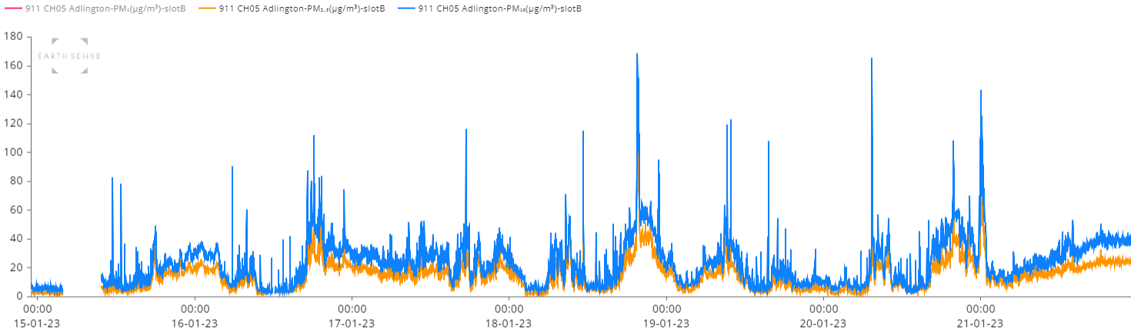
Figure 3a: 15-minute averaged data for PM2.5 and PM10 one week (15th-22nd) in January 2023 (CH05)
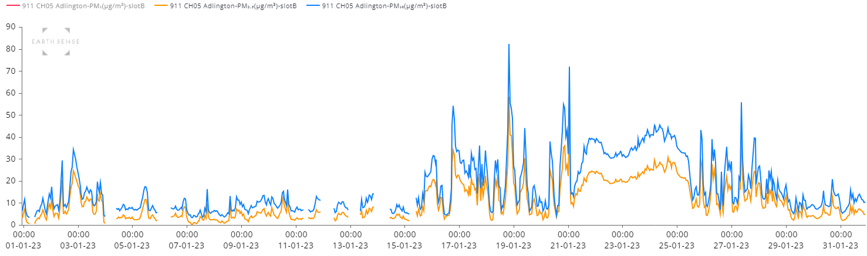
Figure 3b: 1-hour averaged data for PM2.5 and PM10 whole month January 2023 (CH05)

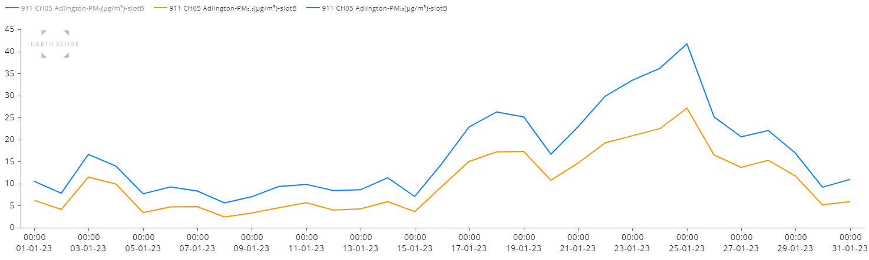
Figure 3c: 24-hour averaged data for PM2.5 and PM10 whole month January 2023 (CH05)

Abnormal Events
  - Within the Zephyr monitor trial there have been several one-off events which have locally affected concentrations of particulate matter.

  - Such events have included the days around bonfire night (where there is increased burning from bonfires and fireworks). Figure 4 shows the 15-minute (top) and 24-hour (bottom) averaged readings taken at CH05 across the 1st to 7th of November.
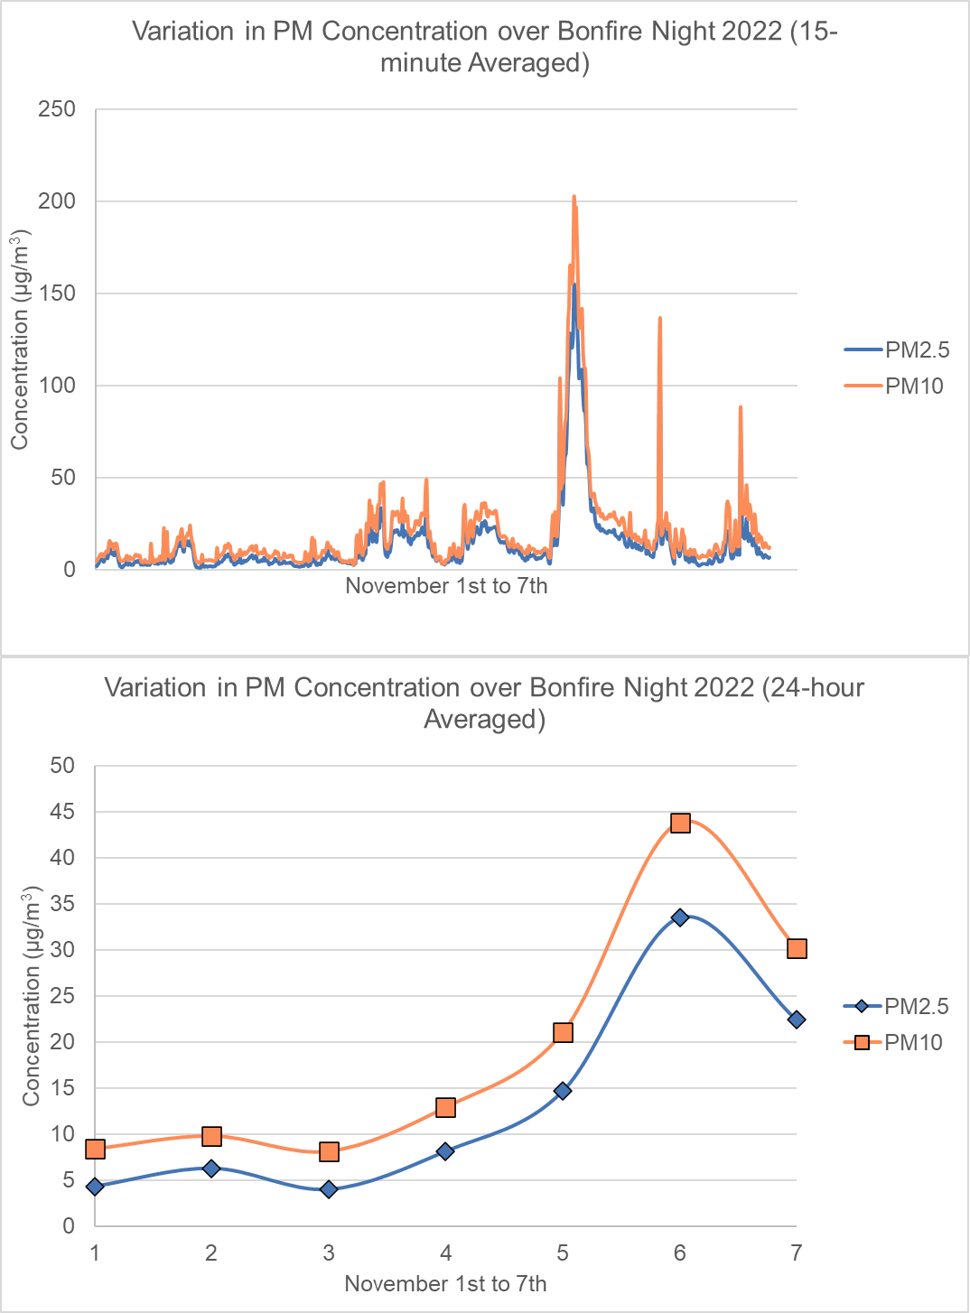
Figure 4: Increase in PM concentrations around Bonfire Night 2022 at CH05.
  - However, as in Section 3.1, due to the transient and time limited nature of these events, there is no overall effect on the time-averaged data for the Borough.

3.3 Seasonal Variation
  - Monthly average PM concentration readings from the Zephyr monitors are presented in Figure 5 for PM_{2.5} and Figure 6 for PM₁₀.

  - The graphs show that concentrations of particulate matter start to increase from October, peak in December and January, start to decrease from March and reach a minimum through July and August.

  - It is recognised that variations in particulate matter concentration are likely to vary across the year in response to increased building heating (from non-electric sources) and fewer people choosing active travel methods in colder months, and less commuting and heating demand in the summer.

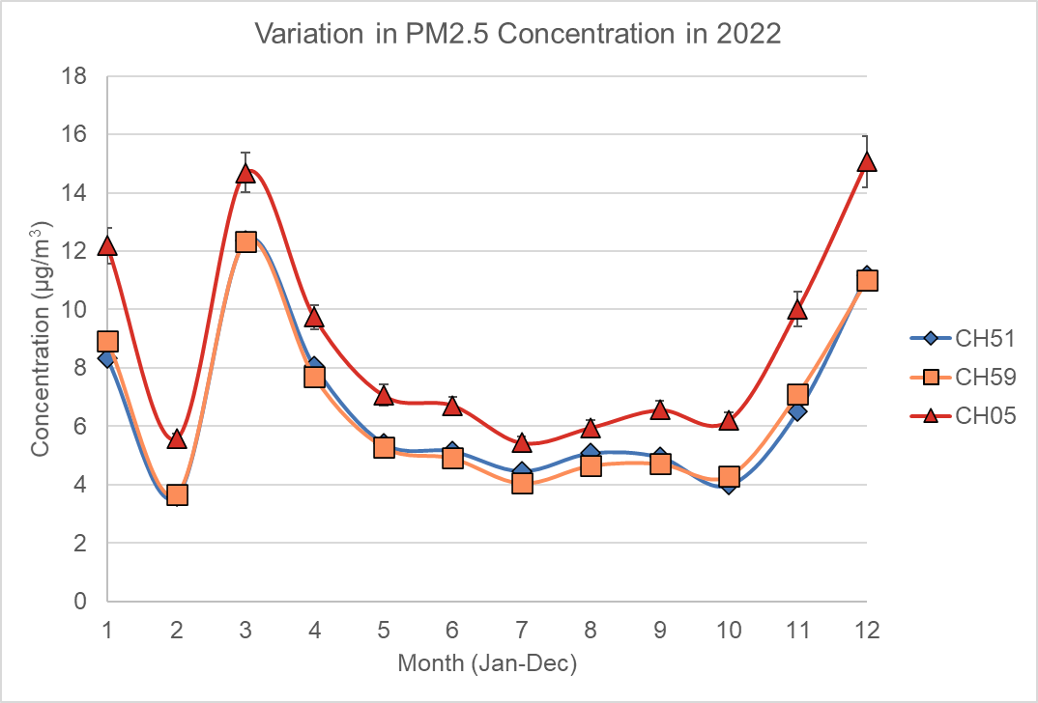
Figure 5: Variation in PM_{2.5} concentrations for all monitoring sites across 2022.
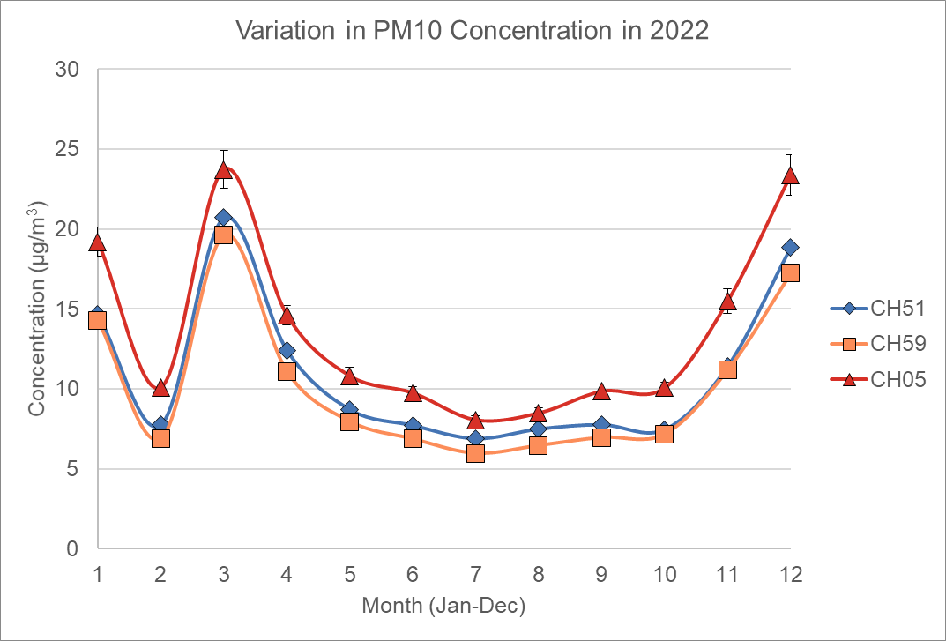
Figure 6: Variation in PM₁₀ concentrations for all monitoring sites across 2022.

  - There is a noticeable reduction in both PM_{2.5} and PM₁₀ concentrations through February 2022, which does not follow the expected trend for the months January to March.

  - From the 29^{th of} January through February 2022, five named storms hit the UK bringing higher than usual windspeeds (Kendon, 2022a and 2022b). These storms would have significantly increased the dispersal of air pollutants, thereby removing PM from the local area.

  - It is unlikely that, during a period of stormy weather, vehicle movements and building heating would have reduced to such a large extent to account for the PM concentrations seen (equivalent to a summer month).

  - To verify these results the PM concentrations were compared with readings taken from the independent DEFRA AURN monitor in Preston (Figure 6). Noticeable reductions in particulate matter concentrations are again seen in February.

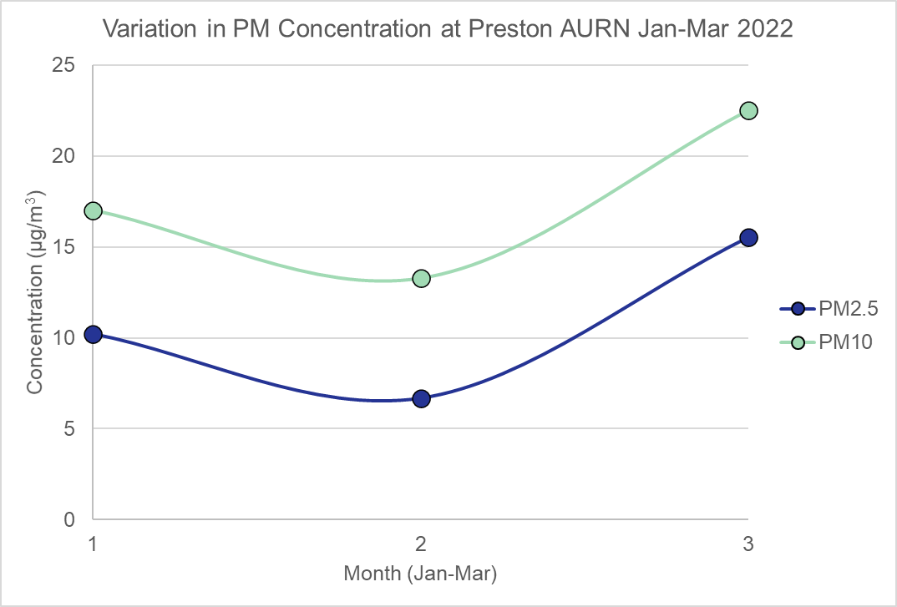
Figure 7: Particulate matter concentrations in Preston over January, February and March 2022.

3.4 Annualised Data
  - Table 4 shows the time-averaged concentrations of particulate matter, as recorded by the Zephyr monitors across 2022. The data is presented in the accepted format following the UK Air Quality Objectives and WHO AQ Guidelines.

  - Annualisation of the data over 365 days removes the uncertainty introduced by the lower than expected readings from February. This was checked by using a theoretical value for February (taking the mean of January and March) and found to have no overall effect on the final annual-averaged figure.

  - There is good agreement in the readings obtained from each of the three monitors. Therefore, there is a high level of confidence that they are representative of the PM concentrations across the Borough.

  - The data shows that the readings for PM₁₀ and PM_{2.5} across the three monitoring locations comply with the UK Air Quality Objectives.

  - There is one 24-hour mean value of 50 µg/m³ at CH05, UK Air Quality Objectives permit up to 35 exceedances above 50 µg/m³ annually. Therefore, while being noteworthy, it does not represent a breach of the objectives.

  - The monitoring data also shows good agreement with the WHO air quality guidelines or the WHO Interim Target 4.
Table 4: Zephyr Particulate Matter Monitor Time-averaged Readings for 2022, compared to UK Air Quality Objectives (AQO) and WHO AQ Guideline Values.
Site ID | Measure | Reading (µg/m³) | Date | Complies UK AQO | Complies WHO AQ Guideline
CH05 | PM10 Annual Mean | 14 | N/A | Yes | Yes
 | PM2.5 Annual Mean | 9 | N/A | Yes | Lower than Interim 4
 | PM10 Highest 24-hour Mean | 50 | 16/12/22 | Yes | Equal Interim 4
 | PM2.5 Highest 24-hour Mean | 34 | 06/11/22 | N/A | Yes
CH51 | PM10 Annual Mean | 11 | N/A | Yes | Yes
 | PM2.5 Annual Mean | 7 | N/A | Yes | Lower than Interim 4
 | PM10 Highest 24-hour Mean | 47 | 24/03/22 | Yes | Lower than Interim 4
 | PM2.5 Highest 24-hour Mean | 28 | 24/03/22 | N/A | Yes
CH59 | PM10 Annual Mean | 10 | N/A | Yes | Yes
 | PM2.5 Annual Mean | 7 | N/A | Yes | Lower than Interim 4
 | PM10 Highest 24-hour Mean | 44 | 22/03/20 & 26/01/22 | Yes | Yes
 | PM2.5 Highest 24-hour Mean | 27 | 06/11/2022 | N/A | Yes

  - Ideally one Zephyr monitor from an array would be located in a background area, away from visible pollutions sources (traffic etc.) to enable a true comparison and for an accurate PM concentration background level to be recorded. This was not possible in this study, as the monitors had already been installed.

  - A significant amount PM results from agricultural activities, as Chorley Borough has a large rural area, the Zephyr monitors located in urban environments are not necessarily showing a true picture of the Borough as a whole. There is however a less dense population in these areas, with receptors (people) further away from sources such as high-traffic areas. Therefore, there is confidence in the results obtained.

  - Going forward for a more detailed study would choose random locations as monitoring sites to reduce location bias and to incorporate a rural area. This recognises the limitations in generating a true exposure profile for suburban or rural areas, as it is unlikely people will be standing at a single busy street junction all day every day.

3.5 Comparison to DEFRA Background maps
  - This quality assurance step has been carried out to confirm that the Zephyr monitors are working as intended and producing reliable results.

  - There is good agreement between the PM concentrations values obtained by the Zephyr monitors and those predicted by the DEFRA background maps (Table 5).
Table 5: Concentrations of PM10 and PM2.5 Predicted by DEFRA Background Maps as a calculated annual mean for the Borough and for each location square which contains a Zephyr PM monitor.
Pollutant | DEFRA Background Map Borough Annual Mean (µg/m³) (Calculated) | DEFRA Background Map Location Square Annual Mean (µg/m³)
 |  | CH05 | CH51 | CH59
PM10 | 10 | 11 | 13 | 11
PM2.5 | 7 | 7 | 8 | 8

  - Locations CH51 and CH59 correspond to the areas with the highest predicted PM_{2.5} concentrations on the DEFRA background maps.

  - Location CH51 corresponds to the area with the highest concentrations of PM₁₀ on the DEFRA background maps. The background map also reports that the area around the bus station in Chorley Town Centre is likely to have similar PM₁₀ levels to CH51.

  - No areas of the DEFRA background maps are predicted to exceed the UK Air Quality Objectives for PM.

  - The locations with the highest predicted reading are areas with large amounts of traffic (i.e., around the M6 Junction 28 and on the A6 through Chorley Town Centre).

  - It should be noted that these readings are based on modelled data and the underlying assumptions may not reflect local events in the real world. For example, it is difficult to know how many wood or solid fuel burners are in an area. The DEFRA models do consider dispersal of pollutants and are a useful indicator of the average exposure levels over time in an area.

4. Conclusions

  - This report presents the results from the trial of EarthSense Zephyr particulate monitors deployed across the Borough for the measurement of both PM₁₀ and PM_{2.5}.

  - No inference is made in this report on the PM source or health effects of the PM levels observed for the Borough. This would require further study.

  - This report will act as a baseline year from which to compare on-going annual concentrations of PM and to identify possible trends.

  - The results obtained show that there are no current concerns regarding exceedances of the UK Air Objectives for PM₁₀ and PM_{2.5}.

  - The quality assurance step shows good agreement between the Zephyr particulate matter readings and the predicted values from the DEFRA background maps.

  - Concentrations of particulate matter rise and fall throughout the year. The highest readings are over the winter months, which reflect the increased usage of non-electric heating systems and vehicles.

  - It is noted that, with three monitors, there will be instances where hyper-local, street-level issues are missed across the Borough. For example, due to topography, street canyons, higher levels of burning in areas etc.

  - Chorley Council continue to rely on resident reports to Environmental Health to identify hotspots where there could be local problems with smoke/particulate pollution.

  - We are trialling Citizenspace to increase public participation in the annual review of monitoring locations and to identify possible new sites.

  - Chorley Council will continue to monitor and report on levels of particulate matter pollution annually and to propose new monitoring locations.

  - The programme of work detailed in both the Clean Air Strategy and Climate Change Strategy includes several actions which will either reduce particulate matter pollution directly or indirectly, in line with national Air Quality Policy Guidance (LAQM.PG22).

  - Residents should continue to heat their homes appropriately to remain safe and healthy.

  - There is advice and support available on the Chorley Council website for tips and ideas on saving energy, sustainable transport options, how to access support for insulation and energy efficiency work and on reducing particulate matter generally.

  - More information, including details of Chorley Council’s air quality and climate change work and how to report nuisance complaints, can be found on the website using this link to the Chorley Air Quality webpage and this link to the Chorley Climate Change webpage.

5. Glossary

Abbreviation | Description
ASR | Annual Status Report
ASR | Annual Status Report
AQ | Air Quality
AQO | Air Quality Objectives
AURN | Automatic Urban and Rural Network monitoring network
DEFRA | Department for Environment, Food and Rural Affairs
LAQM | Local Air Quality Management
NO₂ | Nitrogen Dioxide
NO_{x} | Nitrogen Oxides
PM | Particulate Matter
PM₁₀ | Airborne particulate matter with an aerodynamic diameter of 10µm or less
PM_{2.5} | Airborne particulate matter with an aerodynamic diameter of 2.5µm or less
US EPA | United States Environmental Protection Agency
UK AIR | United Kingdom Air Information Resource
WHO | World Health Organisation

6. References
Air Quality Expert Group. (2018). Air Pollution from Agriculture. Retrieved from https://uk-air.defra.gov.uk/assets/documents/reports/aqeg/2800829_Agricultural_emissions_vfinal2.pdf
DEFRA. (2018). Background Mapping data for local authorities. Retrieved from https://uk-air.defra.gov.uk/data/laqm-background-maps?year=2018
DEFRA. (2022). England (exc. London) Policy Guidance. Retrieved from https://laqm.defra.gov.uk/air-quality/featured/england-exc-london-policy-guidance/
DEFRA. (2023a). Particulate matter (PM10/PM2.5). Retrieved from https://www.gov.uk/government/statistics/air-quality-statistics/concentrations-of-particulate-matter-pm10-and-pm25
DEFRA. (2023b). Emissions of air pollutants in the UK – Particulate matter. Retrieved from https://www.gov.uk/government/statistics/emissions-of-air-pollutants/emissions-of-air-pollutants-in-the-uk-particulate-matter-pm10-and-pm25
DEFRA. (2023c). Emissions of air pollutants in the UK – Ammonia (NH3). Retrieved from https://www.gov.uk/government/statistics/emissions-of-air-pollutants/emissions-of-air-pollutants-in-the-uk-ammonia-nh3#trends-in-total-annual-emissions-of-ammonia-in-the-uk-1980-to-2021
Kelly, J. M., Marais, E. A., Lu, G., Obszynska, J., Mace, M., White, J., & Leigh, R. J. (2023). Diagnosing domestic and transboundary sources of fine particulate matter (PM2.5) in UK cities using GEOS-Chem. City and Environment Interactions, 100100.
Kendon, M. (2022a). Storm Malik and storm Corrie, January 2022. Met Office National Climate Information Centre.
Kendon, M. (2022b). Storms Dudley, Eunice and Franklin, February 2022. Met Office National Climate Information Centre.
Lancashire County Council. (2022). Air quality Summary of emissions data. Retrieved from https://www.lancashire.gov.uk/lancashire-insight/environment/air-quality/
Local Government Association. (2023, June). Climate Change in Chorley. Retrieved from https://lginform.local.gov.uk/reports/view/lga-research/lga-research-report-climate-change-1?mod-area=E07000118&mod-group=AllDistrictInRegion&mod-type=comparisonGroupType#text-54
See the Air. (2021). See the Air blog. Retrieved from https://seetheair.files.wordpress.com/2021/03/particle-penetration.jpg
UK AIR. (n.d.). Automatic Urban and Rural Network (AURN). Retrieved from https://uk-air.defra.gov.uk/networks/network-info?view=aurn
UK AIR. (n.d.). UK Air Quality Limits. Retrieved from https://uk-air.defra.gov.uk/air-pollution/uk-eu-limits
UK Government. (2023). The Environmental Targets (Fine Particulate Matter) (England) Regulations 2023. Retrieved from https://www.legislation.gov.uk/uksi/2023/96/contents/made
US EPA. (2023). Particulate Matter (PM) Basics. Retrieved from https://www.epa.gov/pm-pollution/particulate-matter-pm-basics
Whitty, C. (2022). Chief Medical Officer's annual report 2022: air pollution. Retrieved from https://www.gov.uk/government/publications/chief-medical-officers-annual-report-2022-air-pollution
World Health Organization. (2021a). WHO global air quality guidelines: particulate matter (‎PM2.5 and PM10)‎, ozone, nitrogen dioxide, sulfur dioxide and carbon monoxide. Retrieved from https://www.who.int/publications/i/item/9789240034228
World Health Organization. (2021b). What are the WHO Air quality guidelines? Retrieved from https://www.who.int/news-room/feature-stories/detail/what-are-the-who-air-quality-guidelines

Chorley Council Air Quality webpages: https://www.chorley.gov.uk/article/1991/Air-quality?ccp=true
Chorley Council Climate Change webpages: https://chorley.gov.uk/ClimateChange

